Policy for Modern Foreign Languages
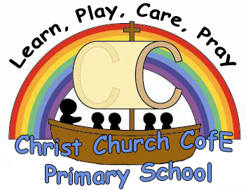

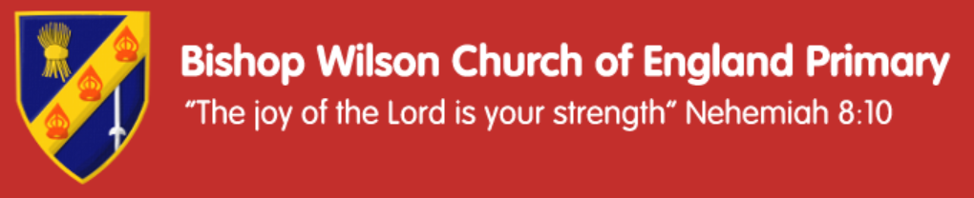

‘
Bishop Wilson CE Primary School | Christ Church CE Primary School
‘The joy of the Lord is your strength’ Nehemiah 8:10  ‘We work, we play we care, we pray’  The joy of the Lord and our Christian values help us to flourish in school and in our community as communicators, explorers, readers and believers | ‘Your word is a lamp to my feet and a light to my path’ Psalm 119  Within God’s family we nurture, teach and support each other, opening doors for all. Our Christian values help us to flourish in school and in our community as beacons radiating the light of Jesus in all that we do.  ‘Learn, play, care, pray in Jesus’ name’

Written by: Rebecca Randles.
Agreed by:
Date: June 2023

Intent
Every child will access a full and diverse curriculum which challenges and develops them to grow academically, personally and socially.
As spiritual beacons and through our curriculum we are all:
- Communicators
- Explorers
- Readers
- Believers
Through MFL we interweave these drivers in as many ways as possible.
For example:
Communicators children will explore how the Spanish language is different to English. Children will learn songs and rhymes to learn new vocabulary. Children will be able to perform their rhymes and songs within class.
Explorers children will learn about a range of Spanish traditions and how festivals they are familiar with are different in Spain. They will have the chance to learn new stories and songs they may not hear in their day to day life.

Reading we encourage children to read new vocabulary based around our chosen Modern Foreign language. Children have the opportunity to learn well known stories such as ‘The Hungry Caterpillar’ in Spanish.
Believers all children will learn how to speak, read and write in another language. Children will be given the opportunity to learn about Spanish traditions. .

Through these drivers and the delivery of the Spanish curriculum we want our children to have a love of learning new languages. They will have a sound understanding of key Spanish vocabulary and grammar. They will be able to read, write and speak the language at their appropriate level.

Implementation
Scheme of Work and Progression
The curriculum that is followed is based on the guidance given in the revised National Curriculum, using the primary languages network scheme of work as a basis. This scheme is used as it has resources and planning for the class teacher to use. Children take part in a range of activities which help them learn the key areas of languages; reading, writing and speaking and listening. There is clear progression in the planning, children are accessing lessons which link to national curriculum objectives. Spanish is the modern foreign language that is taught in our school..
Provision for reception – to be able to greet people and say goodbye.

Planning
Planning can be found on rachelhawkes.com. The planning is also available in a staff share file named MFL. Teachers must use this planning as it is key to progression throughout the school.

Teaching and Learning
KS2 children have a regular thirty minutes lesson of modern foreign language a week, in order to ensure progression and skills development. The lesson will be taught by the class teacher at a time of their choice. These objectives can be taught using the rachelhawkes.com planning to help. The planning should be followed properly as it gives children opportunities to meet our drivers; for example children not only learn the language but also learn traditions in Spanish countries. Children are also given the chance to present ideas, songs, phrases and rhyme to audiences. Nevertheless, teachers can be creative with their approaches, using other resources and ideas which link to the lessons planned in the scheme of work.
Children will be taught to:
- listen attentively to spoken language and show understanding by joining in and responding
- explore the patterns and sounds of language through songs and rhymes and link the spelling, sound and meaning of words
- engage in conversations; ask and answer questions; express opinions and respond to those of others; seek clarification and help
- speak in sentences, using familiar vocabulary, phrases and basic language structures
- develop accurate pronunciation and intonation so that others understand when they are reading aloud or using familiar words and phrases
- present ideas and information orally to a range of audiences –
- read carefully and show understanding of words, phrases and simple writing.
- appreciate stories, songs, poems and rhymes in the language
- broaden their vocabulary and develop their ability to understand new words that are introduced into familiar written material, including through using a dictionary
- write phrases from memory, and adapt these to create new sentences, to express ideas clearly
- describe people, places, things and actions orally

Inclusivity
All KS2 pupils shall have the opportunity to develop MFL capability. Children with other languages at home are encouraged to use them for educational benefit and parents are offered advice about what is appropriate. Tasks should be differentiated when needed, (these resources can be found on rachelhawkes.com). Groupings for MFL will generally follow the same pattern as for all lessons. It is appropriate to match pairs of equal ability, and it is also appropriate to plan to have peer tutors for some lessons where the objectives also enable the more able user to learn by specifically teaching. Teachers can use resources such as talking tins and Spanish dictionaries to help children struggling.

Resources
All Spanish resources are currently stored in the resources cupboard. If needed, there are extra resources for teachers to use from other schemes of work. Resources are included on the rachelhawkes.com website. Use of resources is monitored in book scrutiny and observation.

Role of the Subject Leader
The role of the subject leader is shown in the following ways:
- Informal discussion with staff and pupil.
- Big Book Scrutiny
- Work sampling
- Classroom observation
- Pupil voice and parent voice annually
- Staff meetings annually
- Data and assessment scrutiny

Impact
Assessment
Most assessment is formative and is used to support teaching and learning and inform future planning. The teacher assesses the children's progress in the target language based on their achievement of the learning objectives in lessons. The teacher is provided with an assessment ‘tick’ chart (EMAGS) to help with this which can be found on emags.com If any written MFL work is produced, it is to be put in the class ‘Spanish Big Book’. Oral work can be recorded and placed in staff share in the file MFL recordings in the class specific folder. They must be appropriately named and dated based on the topic.
Evidence of Work
If any written MFL work is produced, it is to be put in the class ‘Spanish Big Book’. Oral work can be recorded and placed in staff share in the file MFL recordings in the class specific folder. They must be appropriately named and dated based on the topic. We expect to see 3-4 pieces of work in the book per half term. Progression through topics is important evidence to support assessment.

Impact on pupils
From previous pupil voice questionnaires children enjoy this subject and the range of activities they do to help them progress and learn a new language. Children have enjoyed whole school ‘Spanish speaking day’ and learning about Spanish food and traditions. Children are eager to learn new languages and this is shown through the evidence in Spanish Big Books.

Reviewed on ______________________

