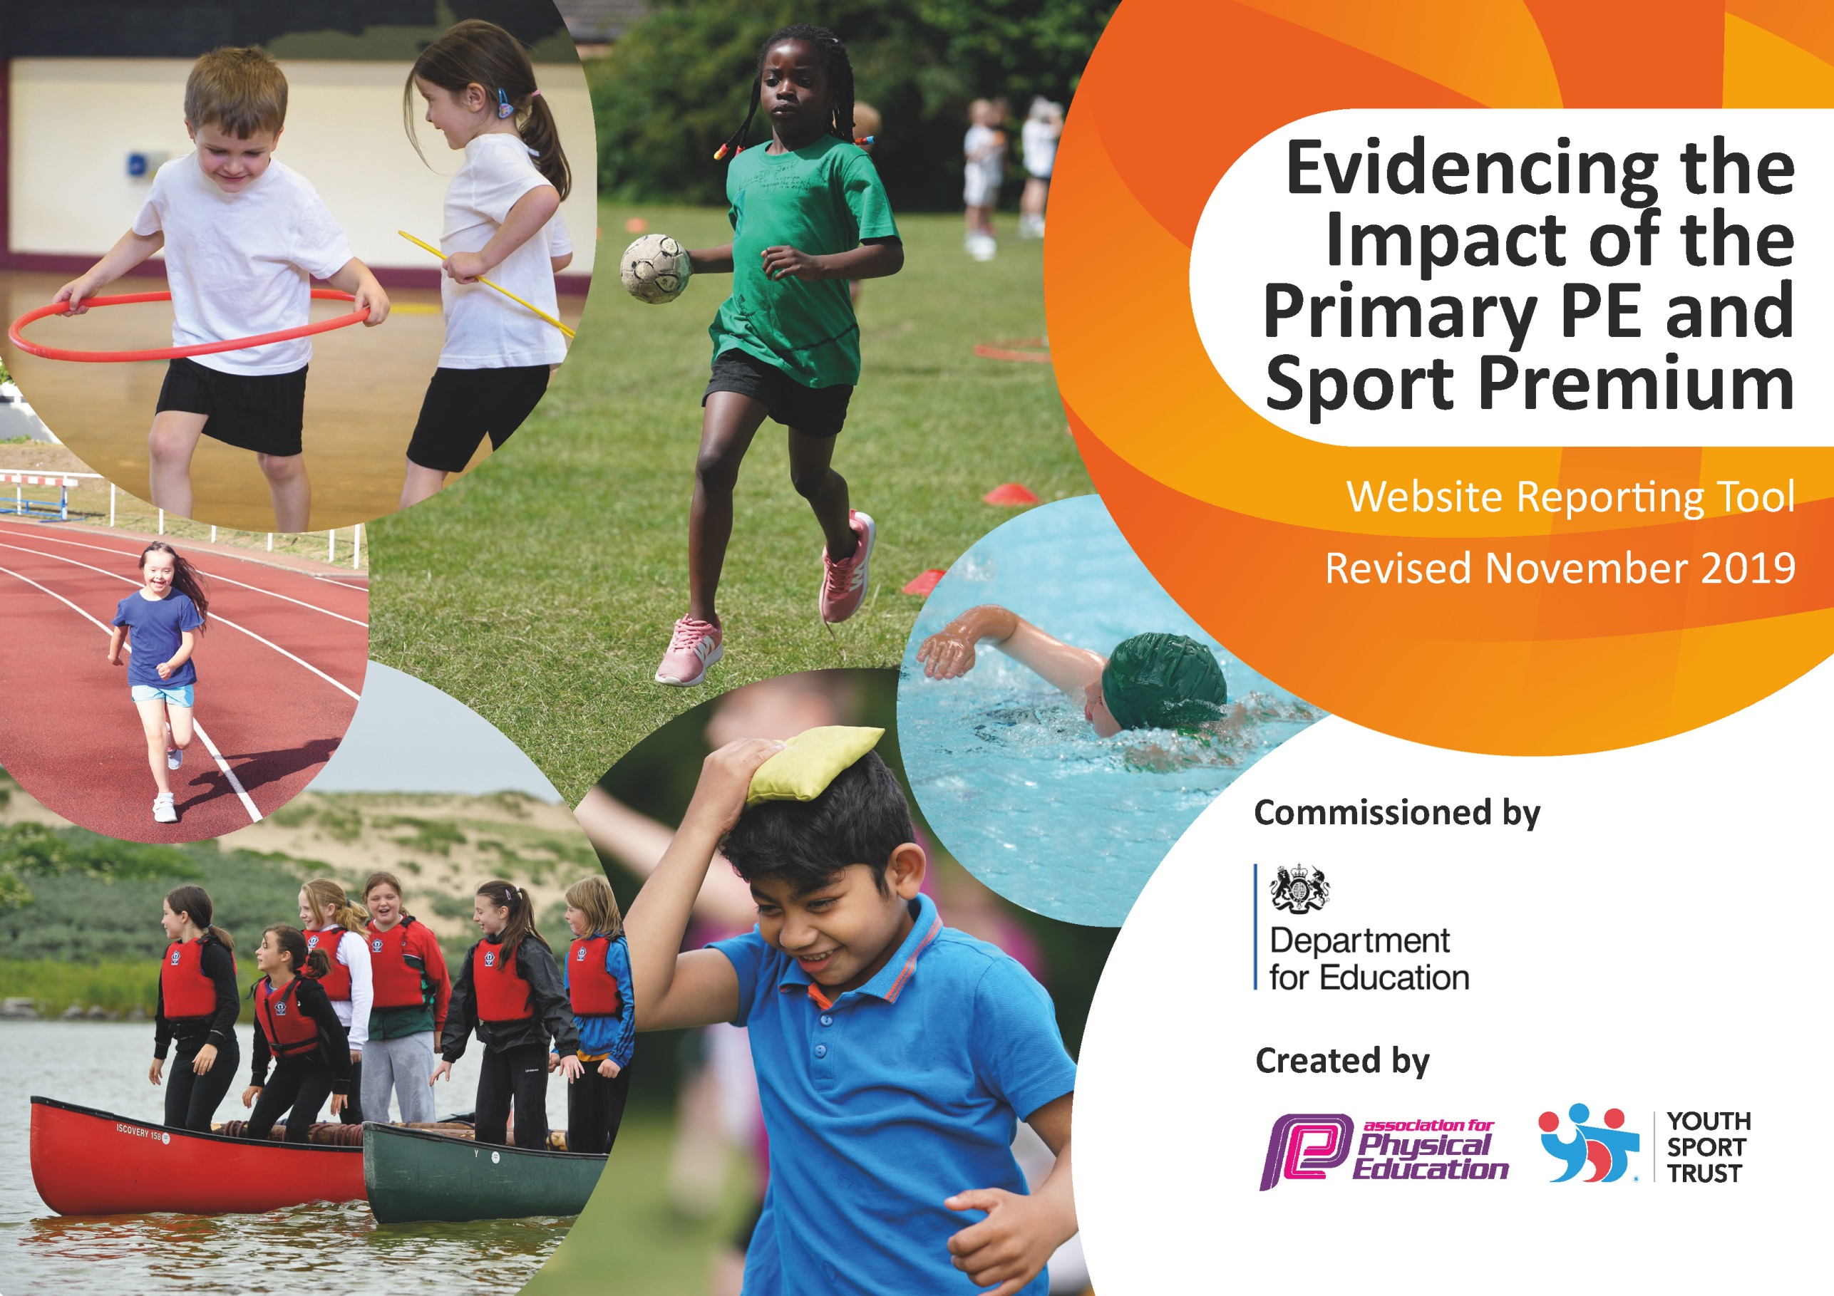
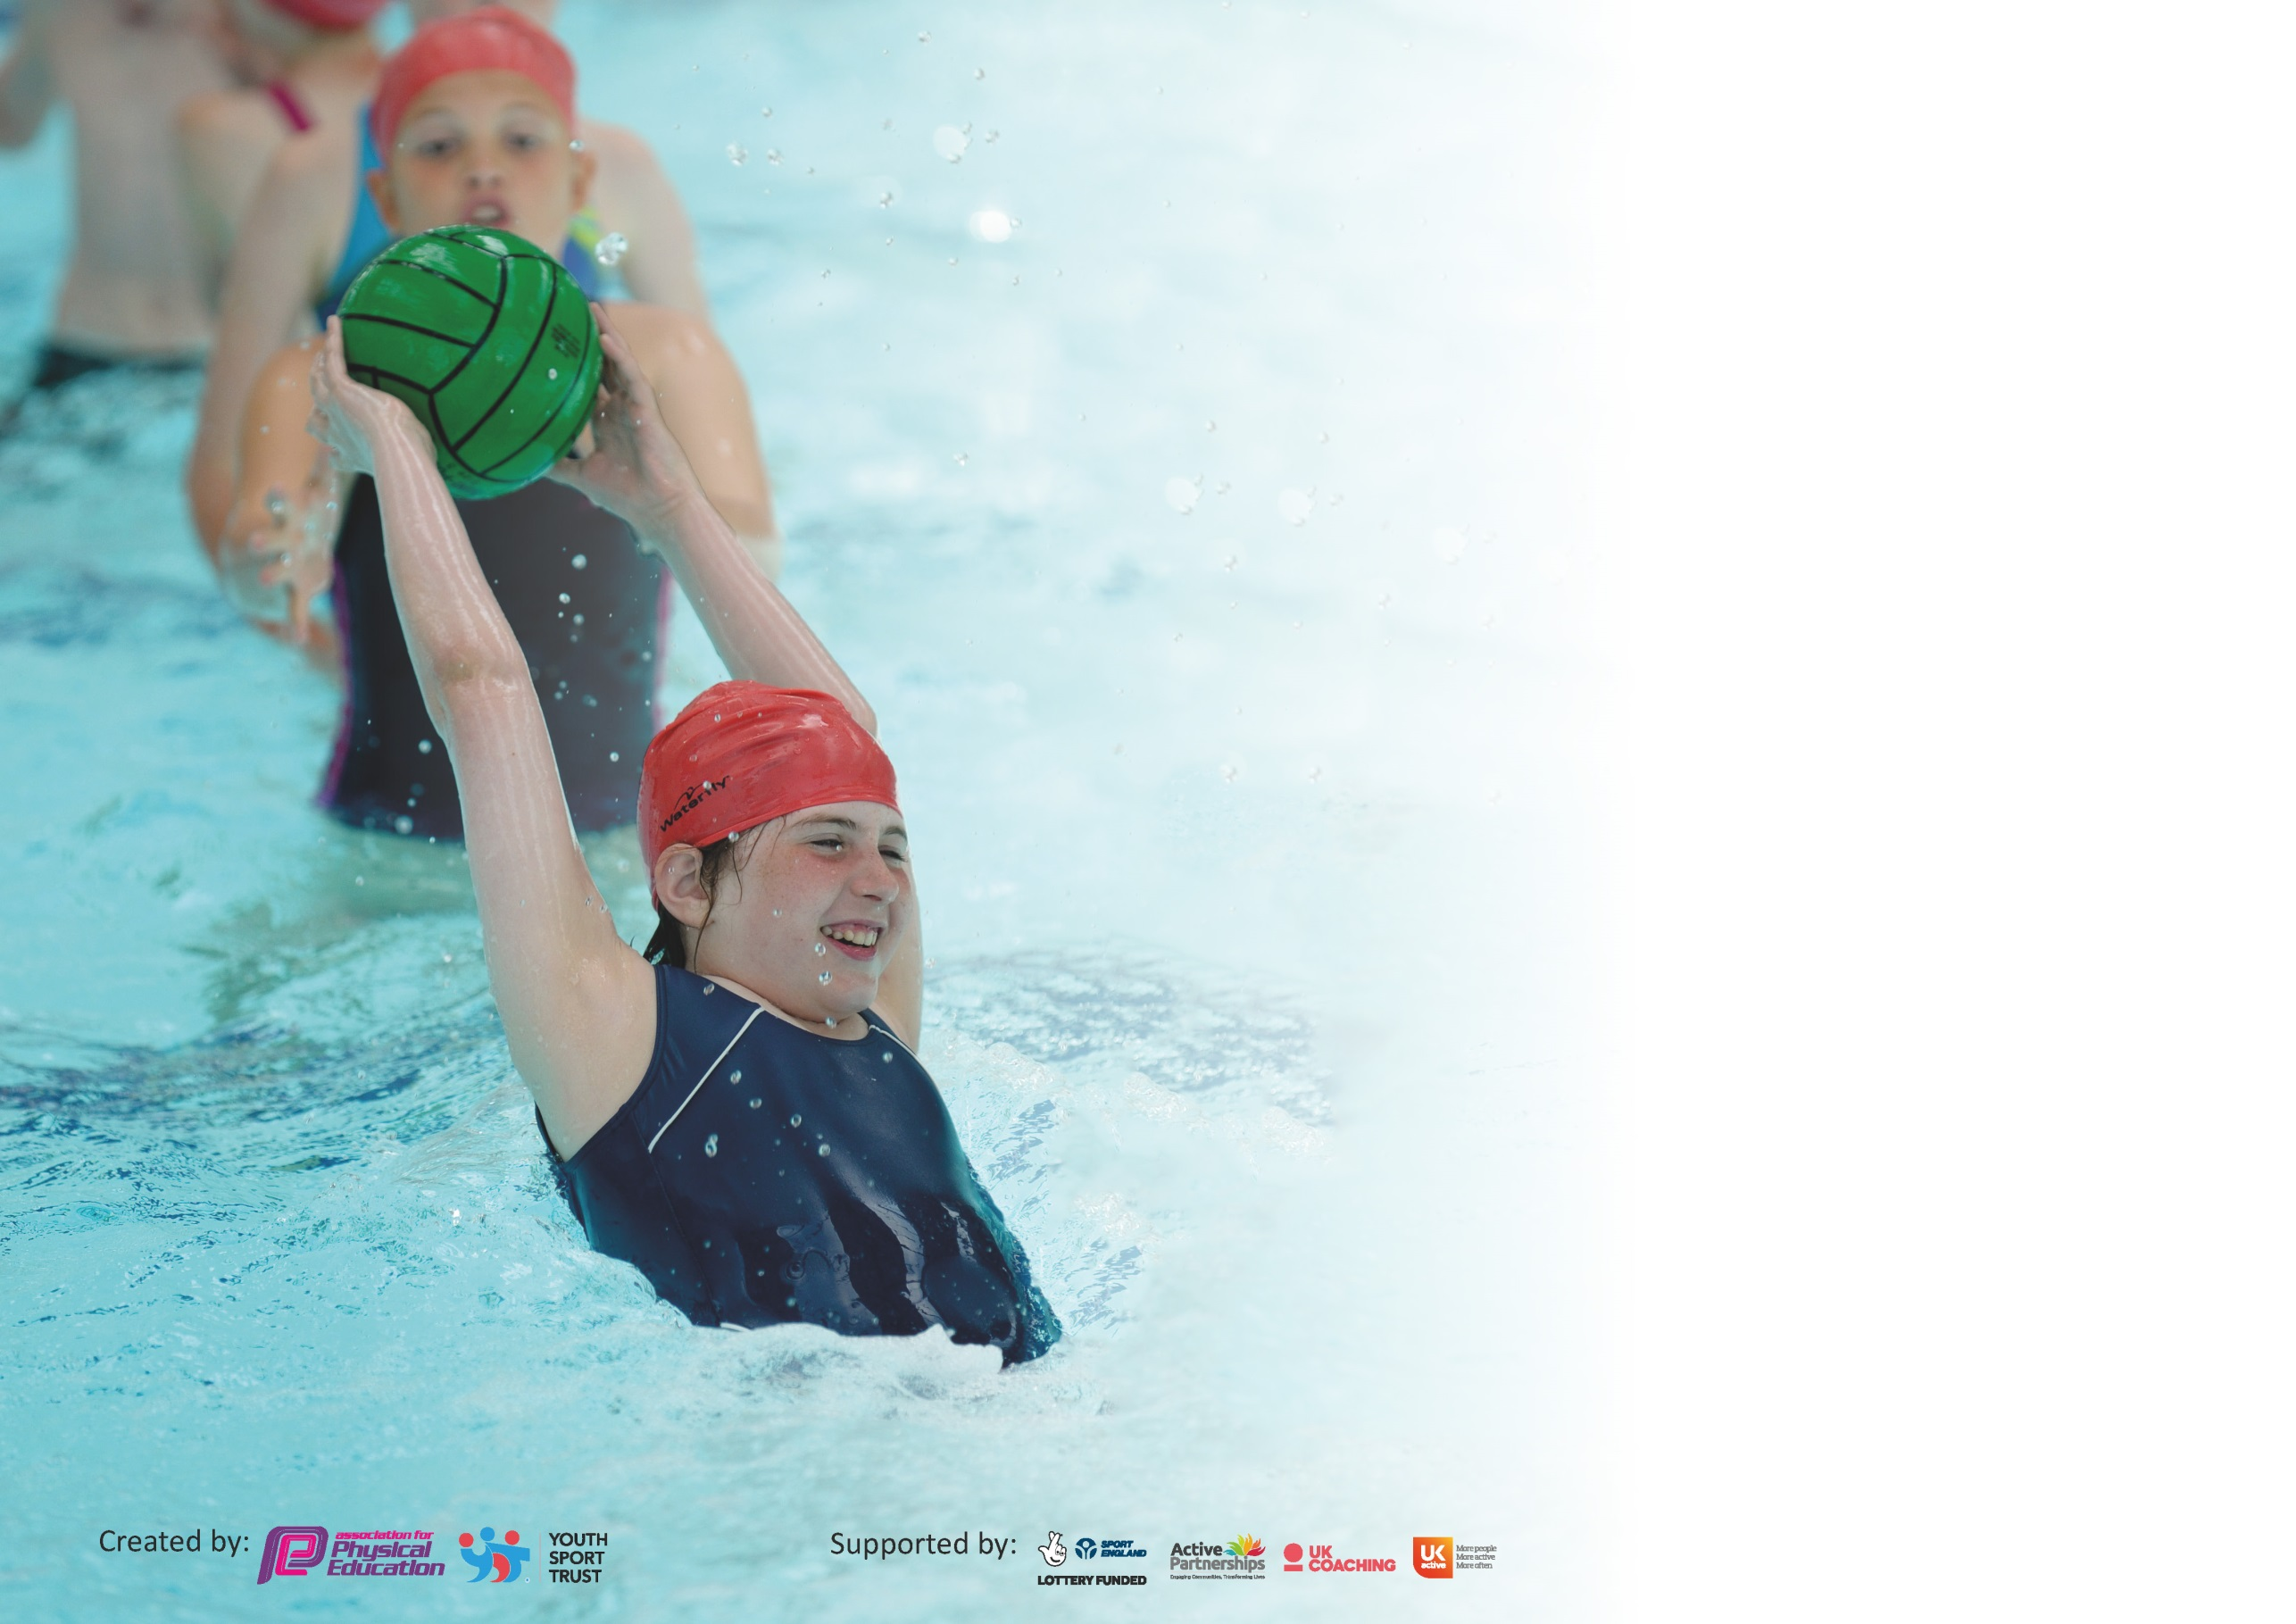

It is important that your grant is used effectively and based on school need. The Education Inspection Framework (Ofsted 2019 p64) makes clear there will be a focus on ‘whether leaders and those responsible for governors all understand their respective roles and perform these in a way that enhances the effectiveness of the school’.

Under the Quality of Education criteria (p41) inspectors consider the extent to which schools can articulate their curriculum (INTENT), construct their curriculum (IMPLEMENTATION) and demonstrate the outcomes which result (IMPACT).

To assist schools with common transferable language this template has been developed to utilise the same three headings which should make your plans easily transferable between working documents.

Schools must use the funding to make additional and sustainable improvements to the quality of Physical Education, School Sport and Physical Activity (PESSPA) they offer. This means that you should
use the Primary PE and Sport Premium to:

- Develop or add to the PESSPA activities that your school already offer
- Build capacity and capability within the school to ensure that improvements made now will benefit pupils joining the school in future years

Please visit gov.uk for the revised DfE guidance including the 5 key indicators across which schools should demonstrate an improvement. This document will help you to review your provision and to report your spend. DfE encourages schools to use this template as an effective way of meeting the reporting requirements of the Primary PE and Sport Premium.

We recommend you start by reflecting on the impact of current provision and reviewing the previous spend.

Schools are required to publish details of how they spend this funding as well as on the impact it has on pupils’ PE and sport participation and attainment by the end of the summer term or by 31st July 2022 at the latest.

We recommend regularly updating the table and publishing it on your website throughout the year. This evidences your ongoing self-evaluation of how you are using the funding to secure maximum, sustainable impact. Final copy must be posted on your website by the end of the academic year and no later than the 31st July 2022. To see an example of how to complete the table please click HERE.

Key achievements to date until July 2022: | Areas for further improvement and baseline evidence of need:
- increased participation in sporting competitions/festivals  - Use of recently-installed outdoor gym equipment  - Achievement of Silver School Games Mark.  - Acquisition and introduction of new scheme of work  - Delivery of House of Dance sessions across both Key Stages (this also provided CPD for staff). | Monitoring of external providers who come in to school to deliver lessons and CPD  Achieve Gold School Games Mark

Meeting national curriculum requirements for swimming and water safety.
What percentage of your current Year 6 cohort swim competently, confidently and proficiently over a distance of at least 25 metres?  N.B. Even though your pupils may swim in another year please report on their attainment on leaving  primary school at the end of the summer term 2022. | 86%
What percentage of your current Year 6 cohort use a range of strokes effectively [for example, front crawl, backstroke and breaststroke]? | 86%
What percentage of your current Year 6 cohort perform safe self-rescue in different water-based situations? | 86%
Schools can choose to use the Primary PE and Sport Premium to provide additional provision for swimming but this must be for activity over and above the national curriculum requirements. Have you used it in this way? | No

Action Plan and Budget Tracking
Capture your intended annual spend against the 5 key indicators. Clarify the success criteria and evidence of impact that you intend to measure to evaluate for pupils today and for the future.

Academic Year: 2021/22 | Total fund allocated: £17 398 | Date Updated: July 2022
Key indicator 1: The engagement of all pupils in regular physical activity – Chief Medical Officer guidelines recommend that primary school pupils undertake at least 30 minutes of physical activity a day in school |  |  |  | Percentage of total allocation:
 |  |  |  | %
Intent | Implementation |  | Impact
It covers all aspects of the National Curriculum. Pupils will learn about dance, athletics, games, swimming, outdoor activities, gymnastics and the life skills needed to succeed both in sport and in future life. | - A range of sports and activities which cover all National Curriculum areas – with appropriate equipment  - Inter-school competition where possible (of varied ability levels) | Funding allocated: | As a result of our curriculum our children have a greater understanding the virtues of competition and self-improvement. They know that sport and physical activity benefit us in many ways | Sustainability and suggested next steps:  Development of partnerships to ensure children and staff have opportunities to sustain opportunities  Develop links with local sporting clubs (eg swimming club, basketball) and using opportunities to develop and enrich what the children have access to in school
Increase sports clubs after school offer | Use external company alongside staff clubs | £1500 | Clubs fully subscribed too, children engaging well. | Focus clubs on the competitions/festivals that the school can engage in
Lunch time games | S4YC coach to promote sports at lunch time – engaging as many children as possible | £2100 | Sporting activities taking place each day | An increase in children now playing competitively – focused on football this year (number of year 6 girls playing)
Key indicator 2: The profile of PESSPA being raised across the school as a tool for whole school improvement |  |  |  | Percentage of total allocation:
 |  |  |  | %
Intent | Implementation |  | Impact
Your school focus should be clear what you want the pupils to know and be able to do and about  what they need to learn and to  consolidate through practice: | Make sure your actions to achieve are linked to your intentions: | Funding allocated: | Evidence of impact: what do pupils now know and what can they now do? What has changed?: | Sustainability and suggested next steps:

Key indicator 3: Increased confidence, knowledge and skills of all staff in teaching PE and sport |  |  |  | Percentage of total allocation:
 |  |  |  | %
Intent | Implementation |  | Impact
Your school focus should be clear | Make sure your actions to | Funding | Evidence of impact: what do | Sustainability and suggested
what you want the pupils to know | achieve are linked to your | allocated: | pupils now know and what | next steps:
and be able to do and about | intentions: |  | can they now do? What has
what they need to learn and to |  |  | changed?:
consolidate through practice:
PE lessons CPD in dance and gymnastics – team teaching lessons on a cyclical basis. | Weekly lessons on dance or gymnastics (rotational basis) – 2 classes per term and then swap | £3500 | All children throughout school engaged in lessons | To cover different aspects of PE  For PE lead to engage in observing the external teachers to ensure quality of provision and to share good practise.
Additional swimming teacher to work alongside staff | Support CPD for staff and improve the teaching and learning for children | £3500 | Children could be taught in smaller groups and therefore positive impact on progress | Continue (there are less children having swimming lessons outside of school)
Key indicator 4: Broader experience of a range of sports and activities offered to all pupils |  |  |  | Percentage of total allocation:
 |  |  |  | %
Intent | Implementation |  | Impact
Your school focus should be clear | Make sure your actions to | Funding | Evidence of impact: what do | Sustainability and suggested
what you want the pupils to know | achieve are linked to your | allocated: | pupils now know and what | next steps:
and be able to do and about | intentions: |  | can they now do? What has
what they need to learn and to |  |  | changed?:
consolidate through practice:
Ensure resources match sports | Audit resources  Purchase equipment as per Complete PE scheme | £748 | Sports lessons took part, children engaged well | Look to extend to other sports – increase use of archery, badminton, volleyball
New scheme of work | To provide children and staff with a broad range of opportunities within PE curriculum | £5078 (2019 budget)  £5498 | Staff confidence increased. Quality of lessons too | Better whole-school approach

Key indicator 5: Increased participation in competitive sport |  |  |  | Percentage of total allocation:
 |  |  |  | %
Intent | Implementation |  | Impact
Your school focus should be clear | Make sure your actions to | Funding | Evidence of impact: what do | Sustainability and suggested
what you want the pupils to know | achieve are linked to your | allocated: | pupils now know and what | next steps:
and be able to do and about | intentions: |  | can they now do? What has
what they need to learn and to |  |  | changed?:
consolidate through practice:
Additional achievements:  To take part in a wide range of sports | Join sports partnership to access activities, festivals and competitions. | £1000 | Competitions and festivals used throughout school | Widen engagement in activities to less mainstream sports

Signed off by
Head Teacher: | H Friend
Date: | 30/7/2022
Subject Leader: | C Madden
Date: | 30/7/2022
Governor: | S Boyle
Date: | 30/7/2022

